Reactjs E-commerce Application

Working Flow/Architecture:

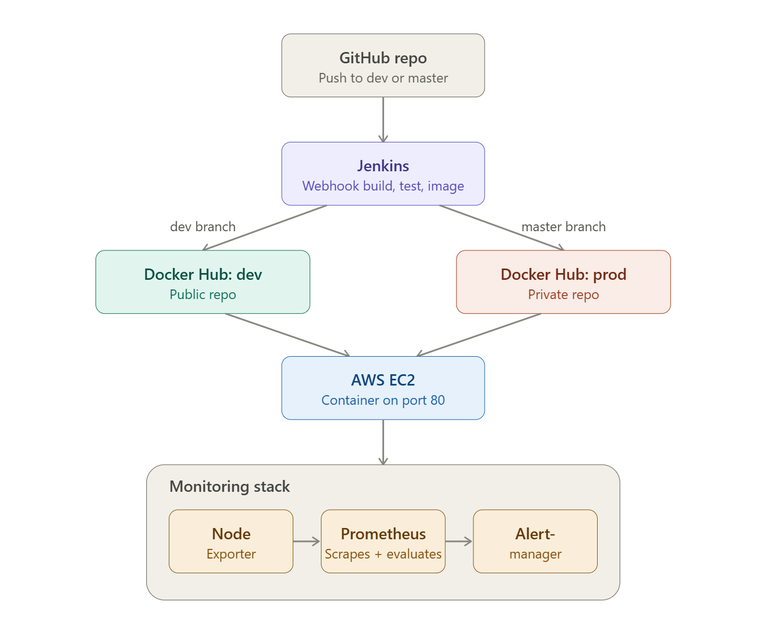

Cloning Github source to local VS

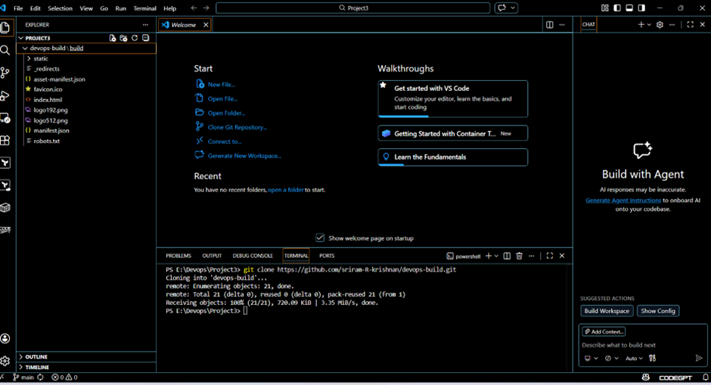

Writing Dockerfile

# Use lightweight nginx image
FROM nginx:alpine

# Remove default nginx website
RUN rm -rf /usr/share/nginx/html/*

# Copy project files into nginx public folder
COPY . /usr/share/nginx/html

# Expose port
EXPOSE 80

# Start nginx
CMD ["nginx", "-g", "daemon off;"]

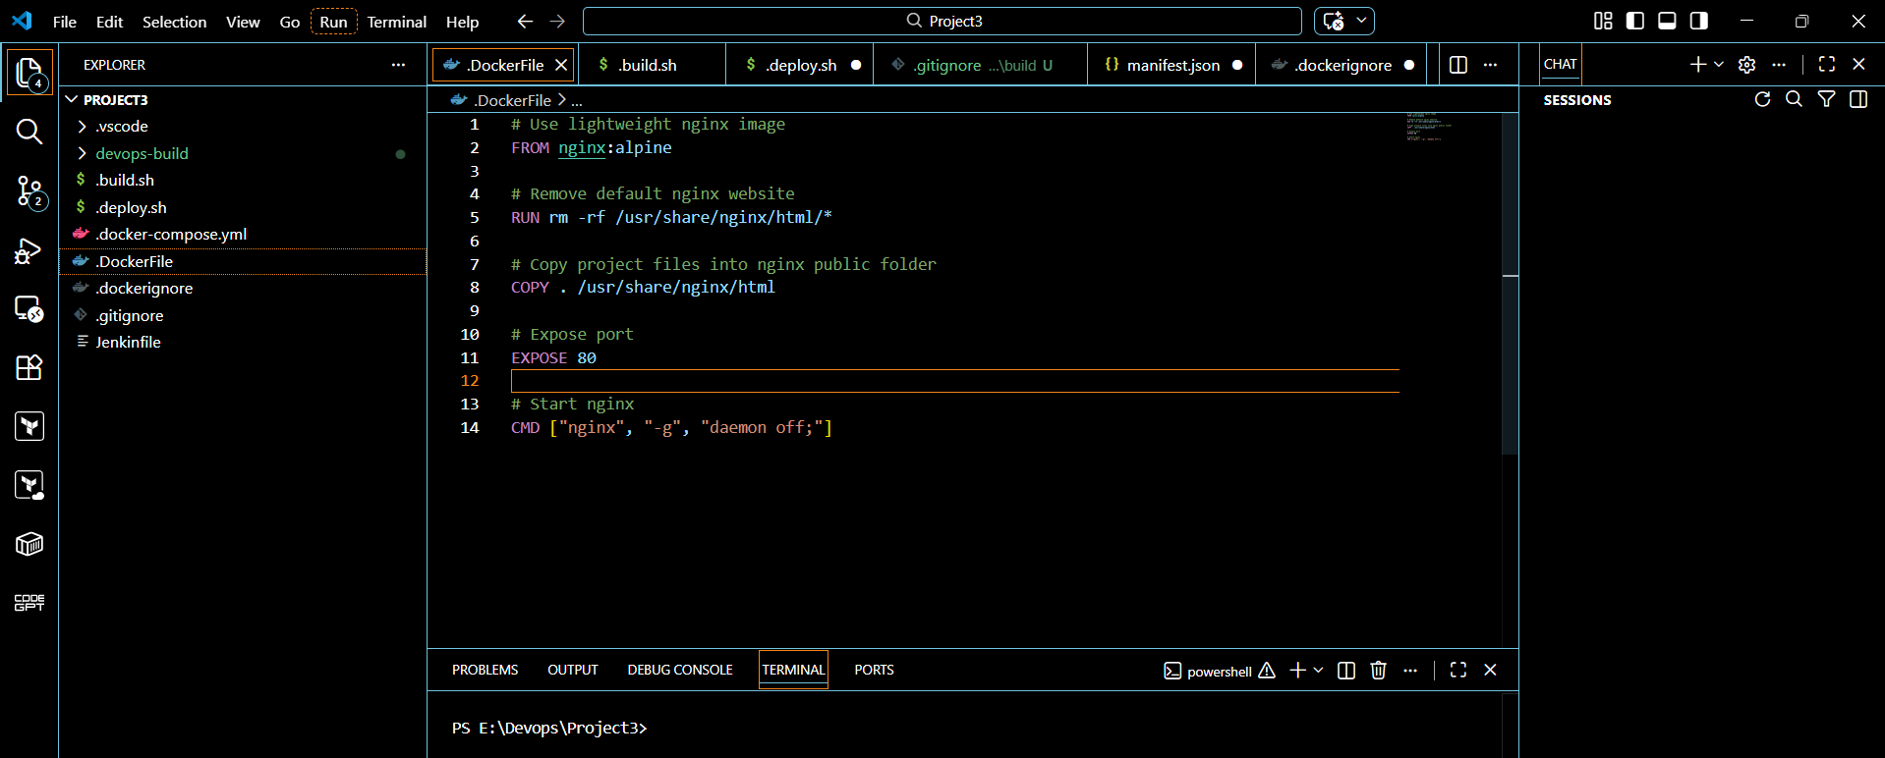

Writing .dockerignore file

node_modules
.git
Dockerfile
README.md

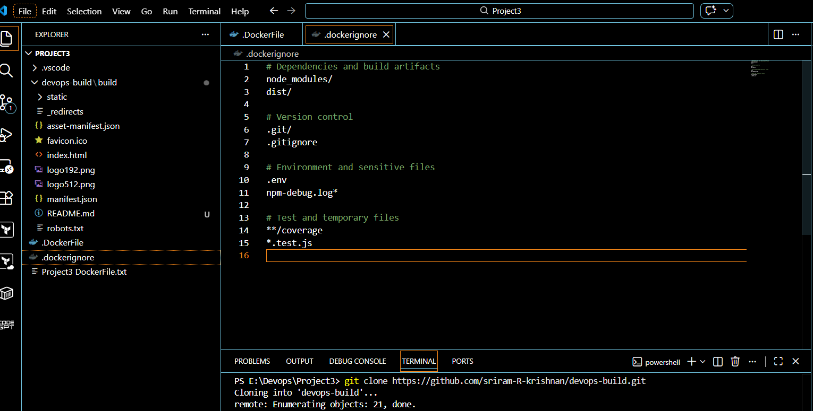

Creating.docker repository:

Dev - Public repository
Prod - Private repository

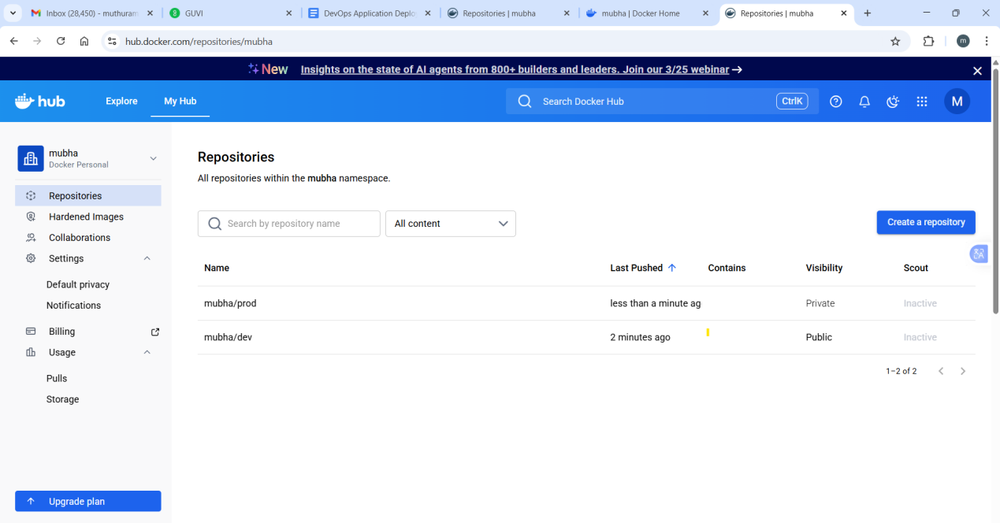

Write JenPkinsfile

pipeline {
agent any

environment {
DEV_REGISTRY = "your-dockerhub-username/dev"
PROD_REGISTRY = "your-dockerhub-username/prod"
IMAGE_NAME = "react-static-app"
IMAGE_TAG = "latest"
}

stages {
stage('Checkout') {
steps {
git url: 'https://github.com/your-org/devops-build.git',
branch: "${BRANCH_NAME}"
}
}

stage('Build Docker Image') {
steps {
sh 'chmod +x build.sh'
sh './build.sh'
}
}

stage('Push to DockerHub') {
steps {
script {
withCredentials([usernamePassword(
credentialsId: 'dockerhub-creds',
usernameVariable: 'DOCKER_USER',
passwordVariable: 'DOCKER_PASS'
)]) {
sh "echo $DOCKER_PASS | docker login -u $DOCKER_USER --password-stdin"

if (env.BRANCH_NAME == 'dev') {
sh "docker tag react-static-app:latest $DEV_REGISTRY:$IMAGE_TAG"
sh "docker push $DEV_REGISTRY:$IMAGE_TAG"
} else if (env.BRANCH_NAME == 'master') {
sh "docker tag react-static-app:latest $PROD_REGISTRY:$IMAGE_TAG"
sh "docker push $PROD_REGISTRY:$IMAGE_TAG"
} else {
echo "Branch is neither dev nor master. Skipping Docker push."
}
}
}
}
}

stage('Deploy') {
steps {
sh 'chmod +x deploy.sh'
sh './deploy.sh'
}
}
}

post {
success {
echo " Deployment completed successfully for branch ${BRANCH_NAME}!"
}
failure {
echo " Pipeline failed. Check logs."
}
}
}

Pushing code to GitHUb

Git init

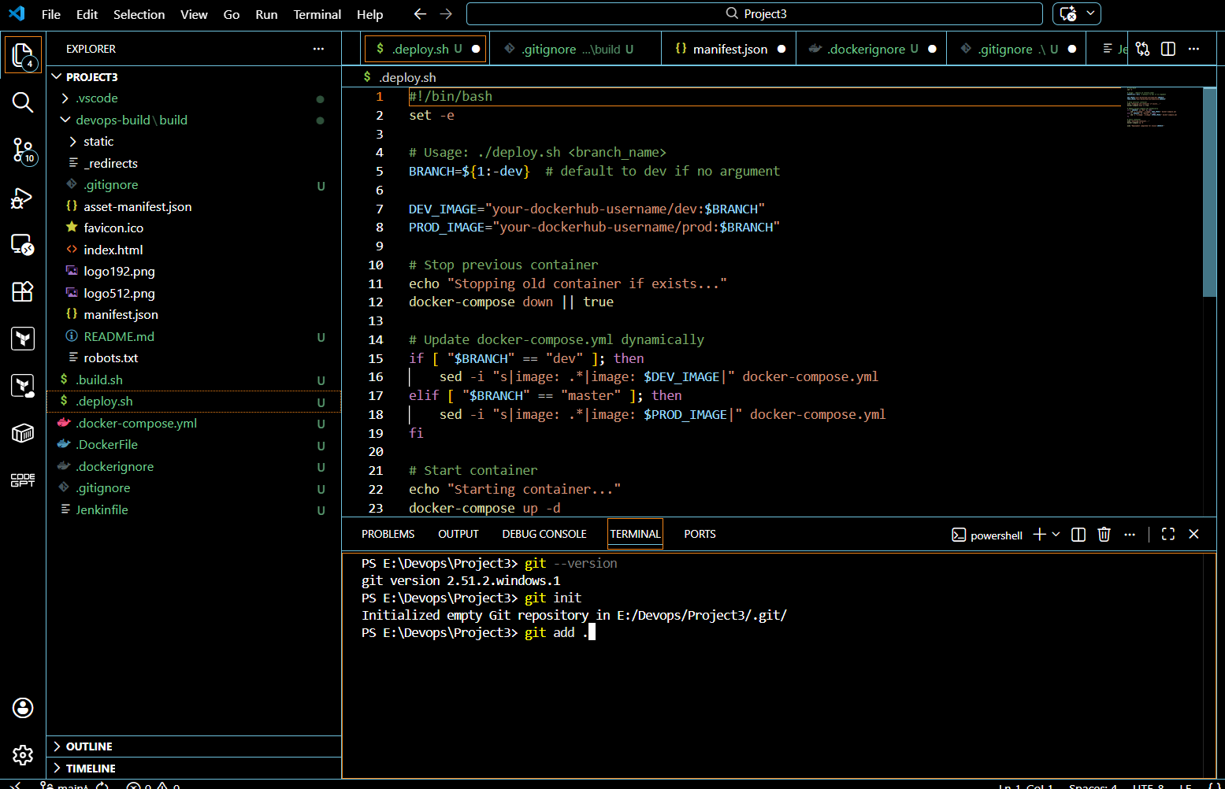

Git add .

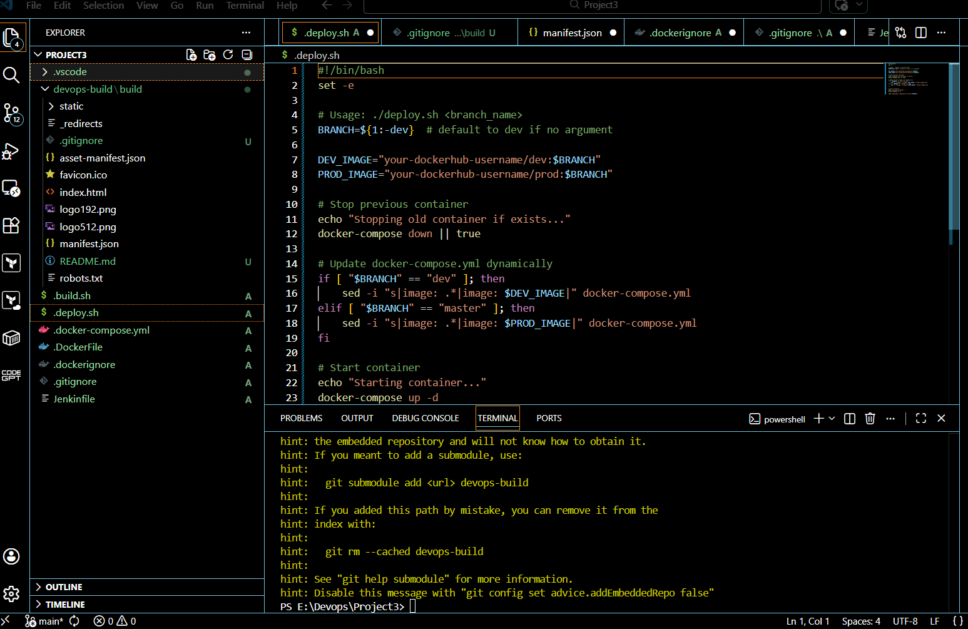

Git commit

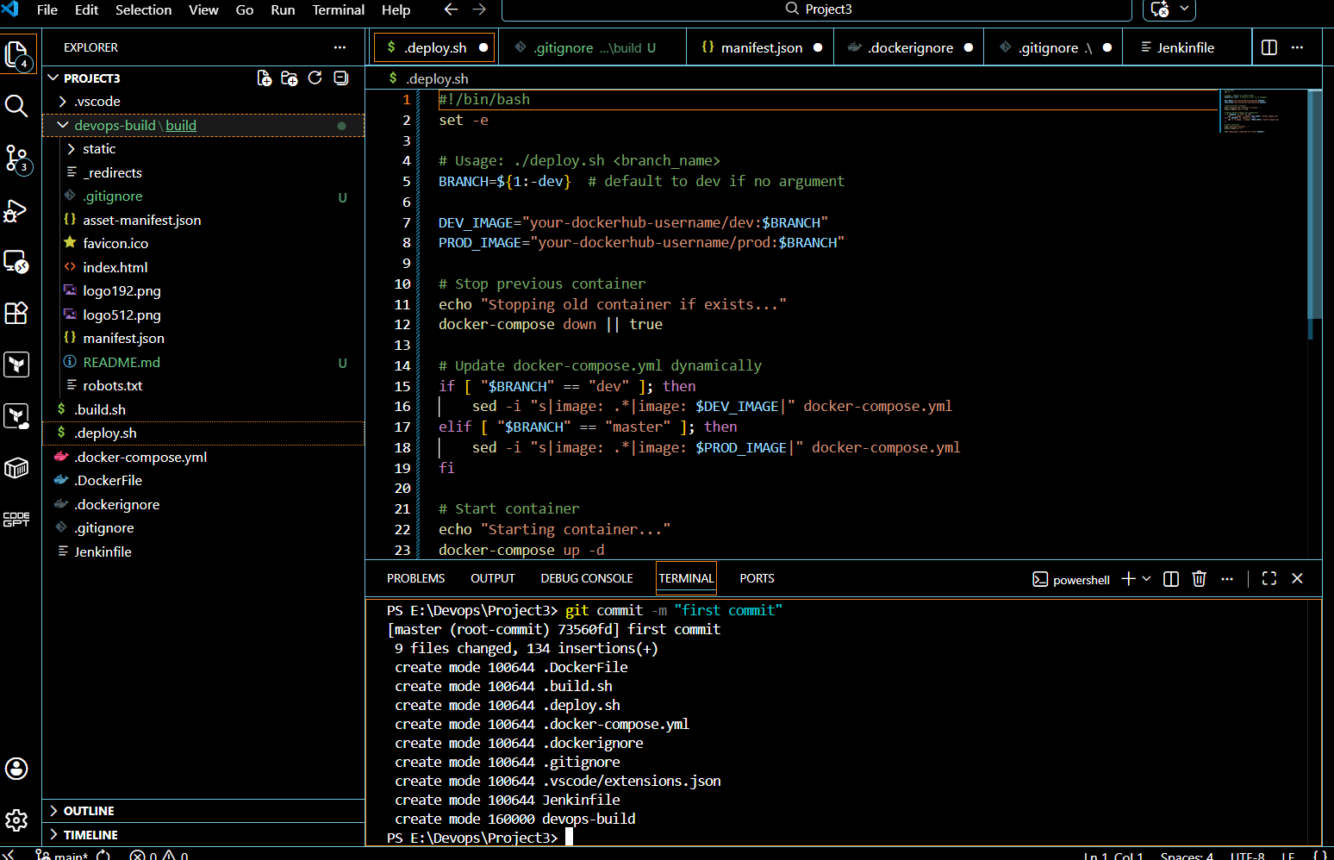

Add origin to the github

git remote add origin https://github.com/devopsmuthuraman/Simple-React-application.git

Github repository before push the code.

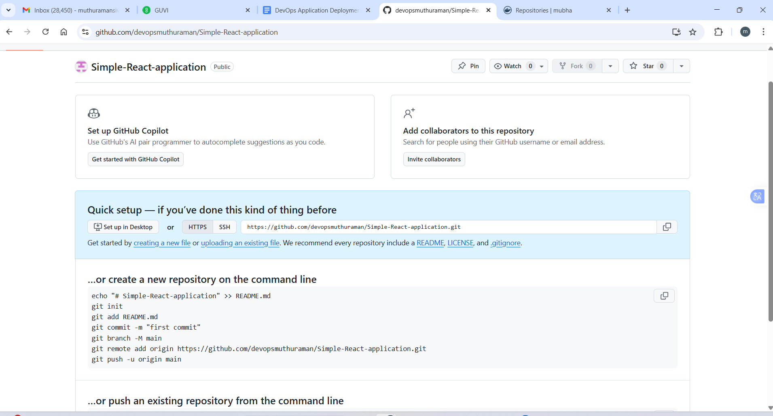

Github repository after pushed code

git push -u origin master

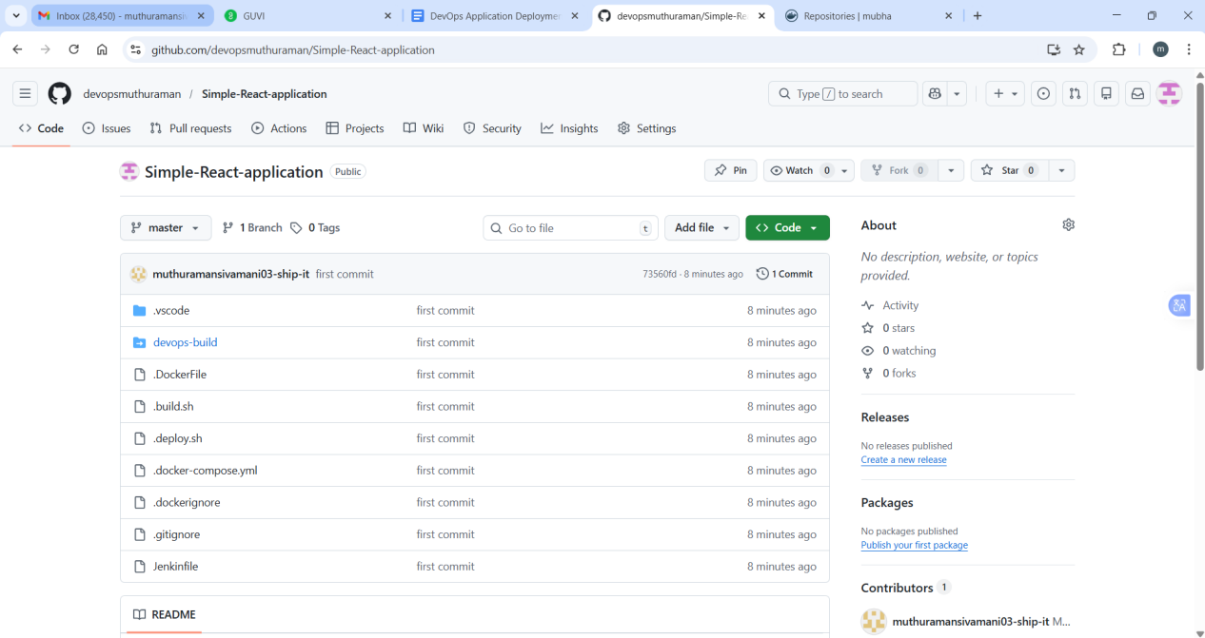

Launch Ec2

T3.Large

Security group
SSH - My IP to login to server SSH
Custom TCP - Anywhere - to access application whoever has ip address

Login server through Putty

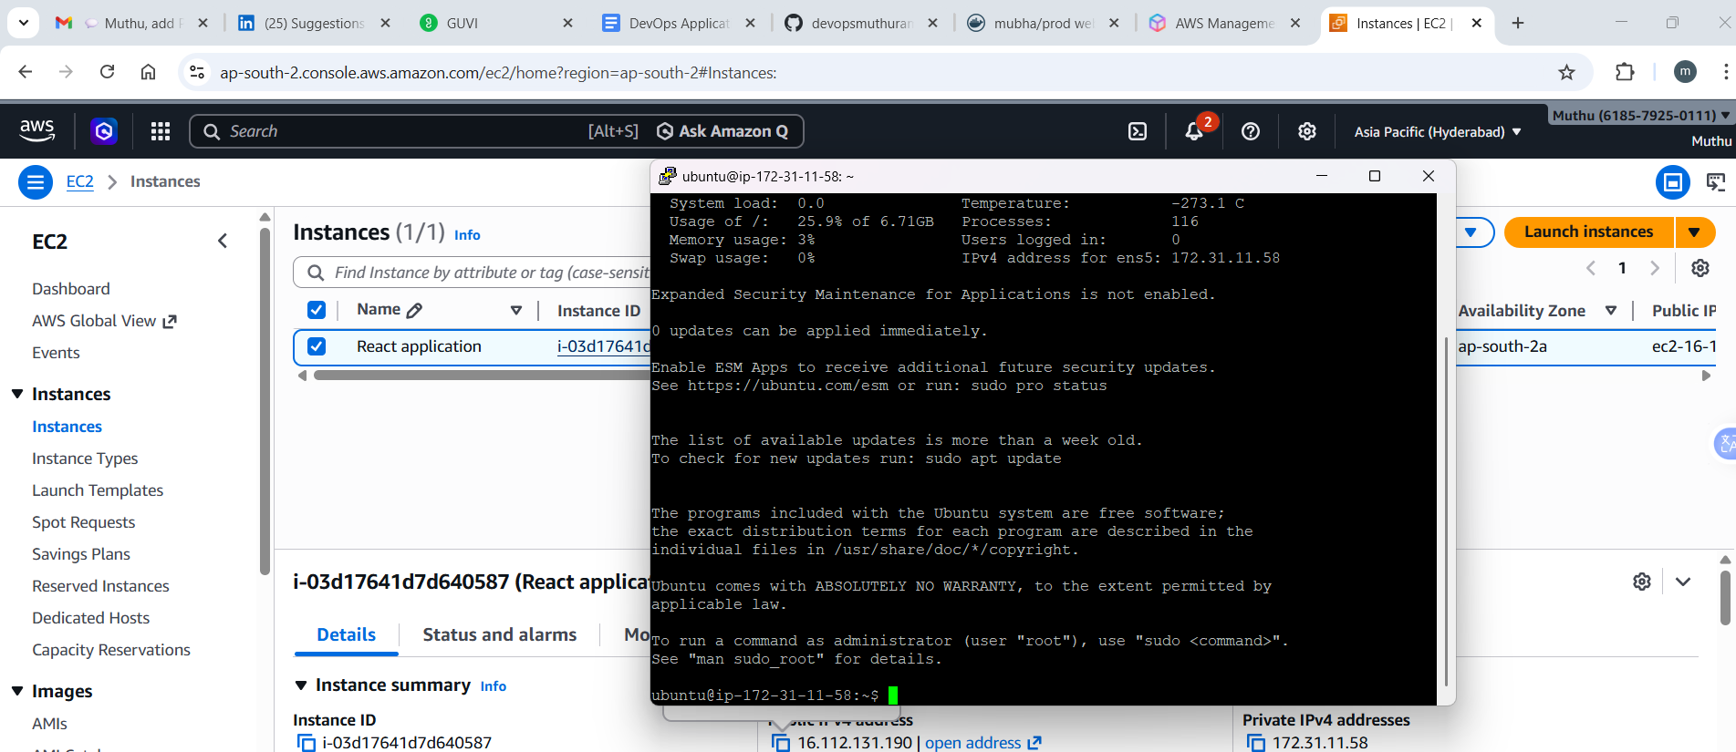

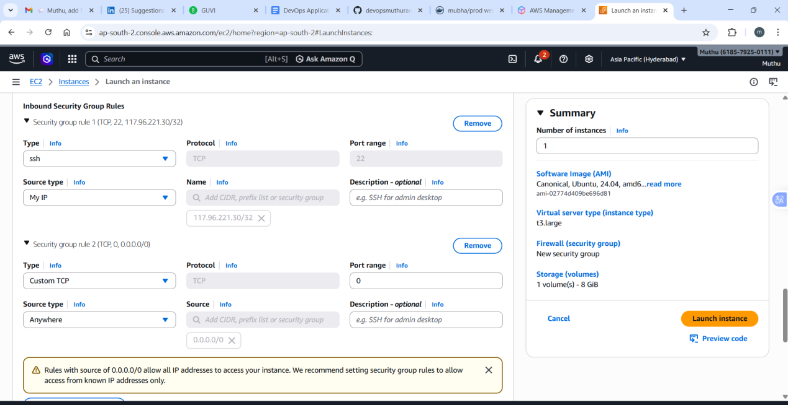

Docker installation
sudo apt-get install docker.io -y
sudo systemctl start docker
sudo systemctl enable docker
docker --version
sudo usermod -a -G docker $(whoami)

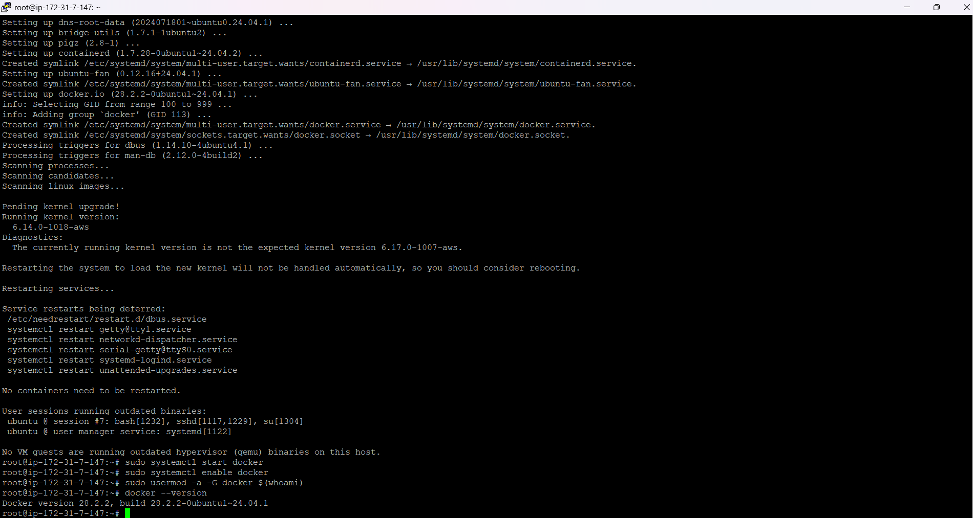

Git install
Sudo apt install git -y
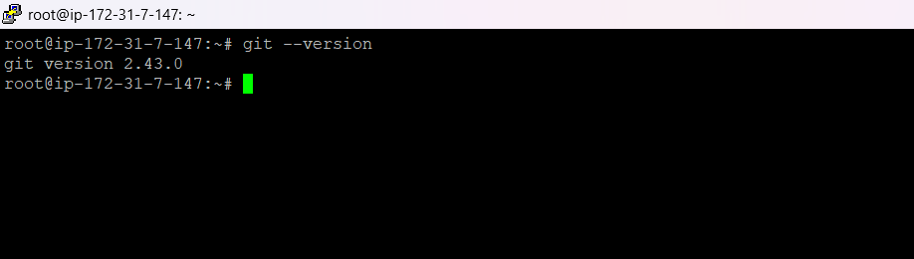

Install Java

sudo apt install fontconfig openjdk-21-jre
java -version

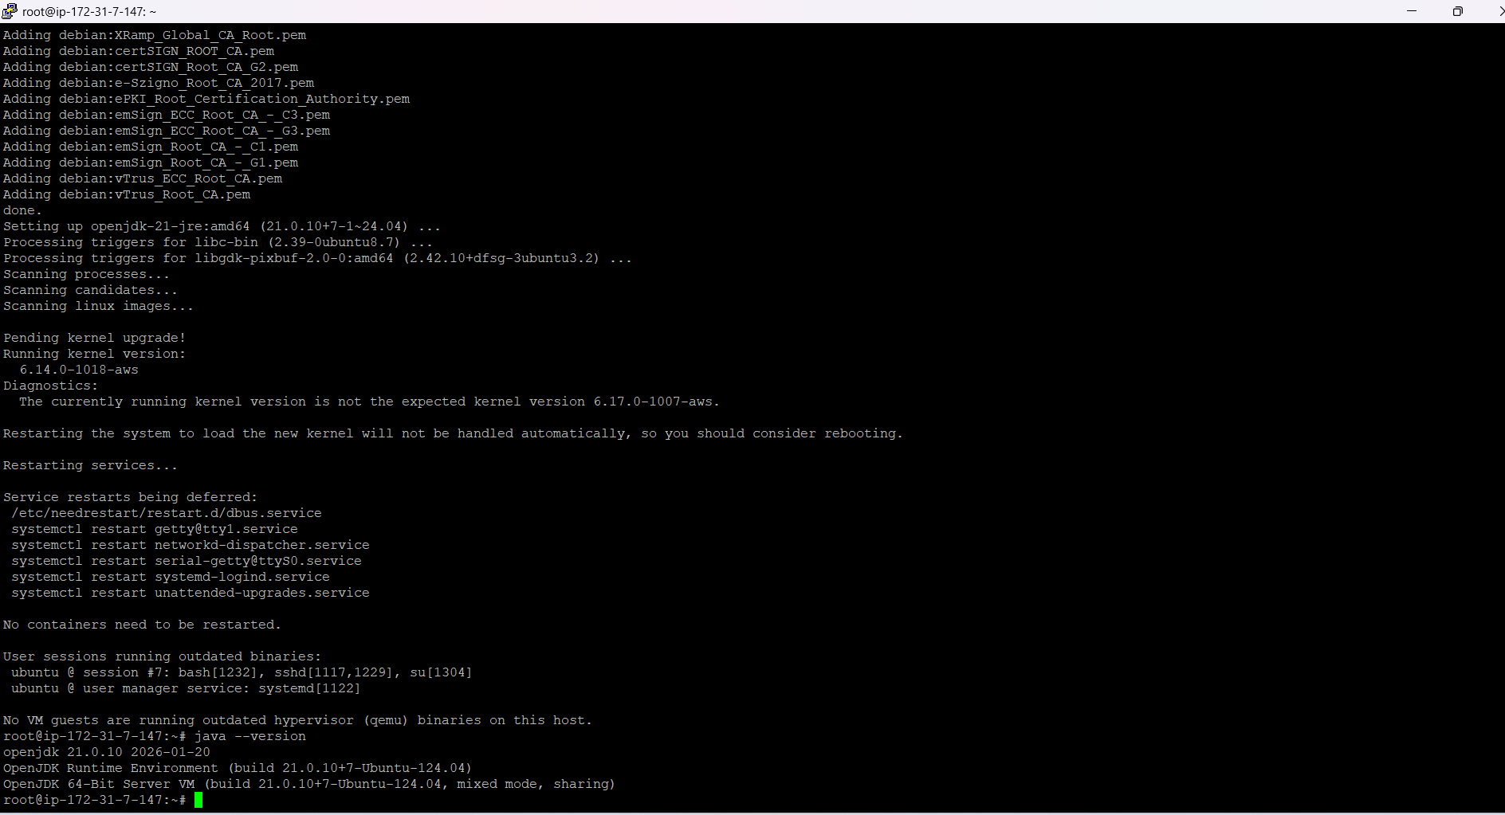

Install Jenkins in machine and installation setup

sudo wget -O /etc/apt/keyrings/jenkins-keyring.asc \
https://pkg.jenkins.io/debian-stable/jenkins.io-2026.key
echo "deb [signed-by=/etc/apt/keyrings/jenkins-keyring.asc]" \
https://pkg.jenkins.io/debian-stable binary/ | sudo tee \
/etc/apt/sources.list.d/jenkins.list > /dev/null

sudo apt update
sudo apt install jenkins

sudo systemctl enable jenkins
sudo systemctl start jenkins
sudo systemctl status jenkins

Access Jenkins which from server DNS

http://<your_server_public_DNS>:8080
http://ec2-18-60-39-102.ap-south-2.compute.amazonaws.com:8080/login?from=%2F

Before create user

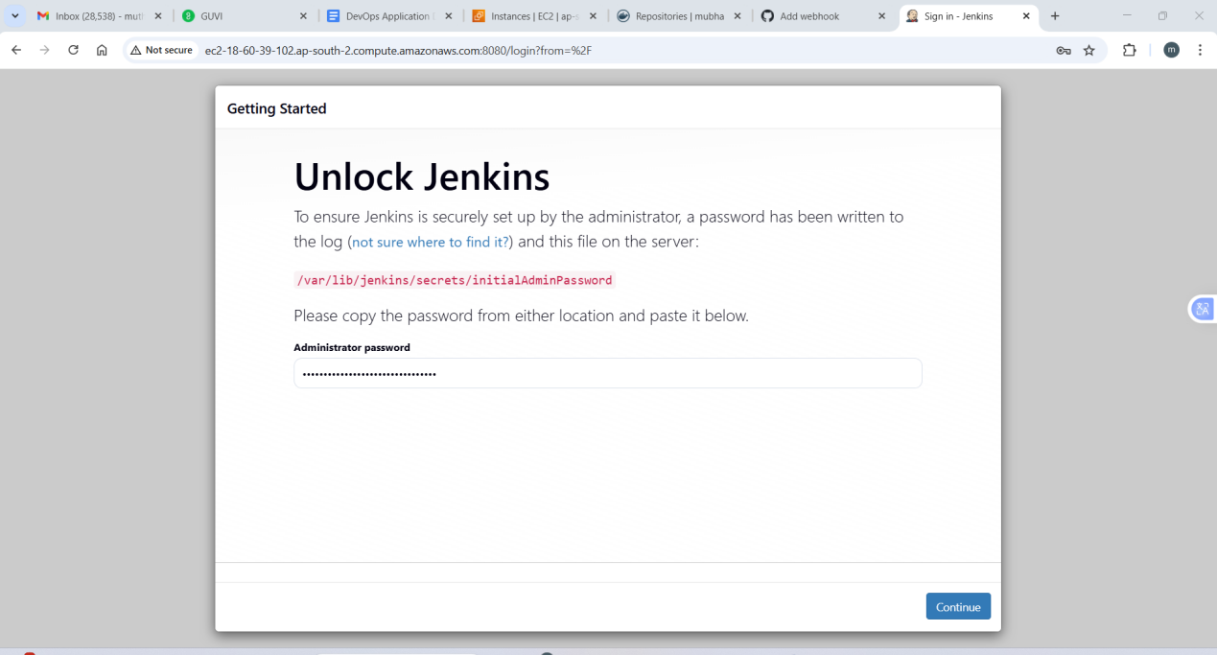

Installing default plugins

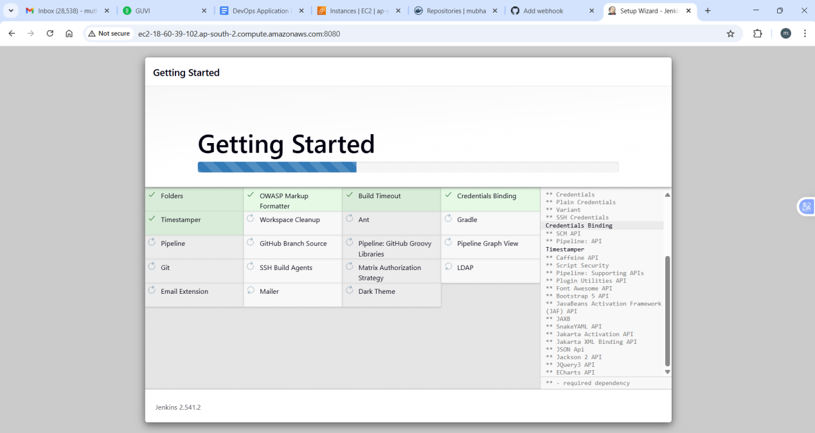

http://ec2-18-60-39-102.ap-south-2.compute.amazonaws.com:8080/

Login page:

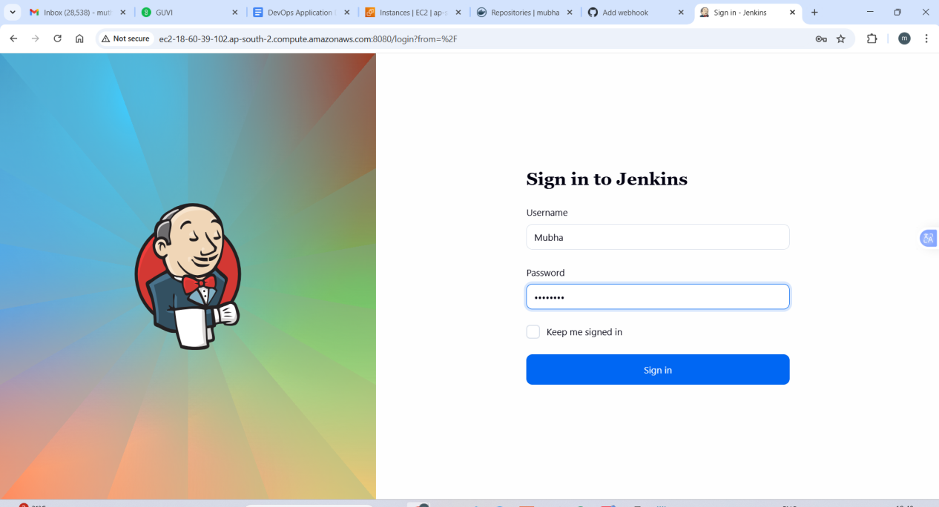

Adding Docker and stageview pipelines

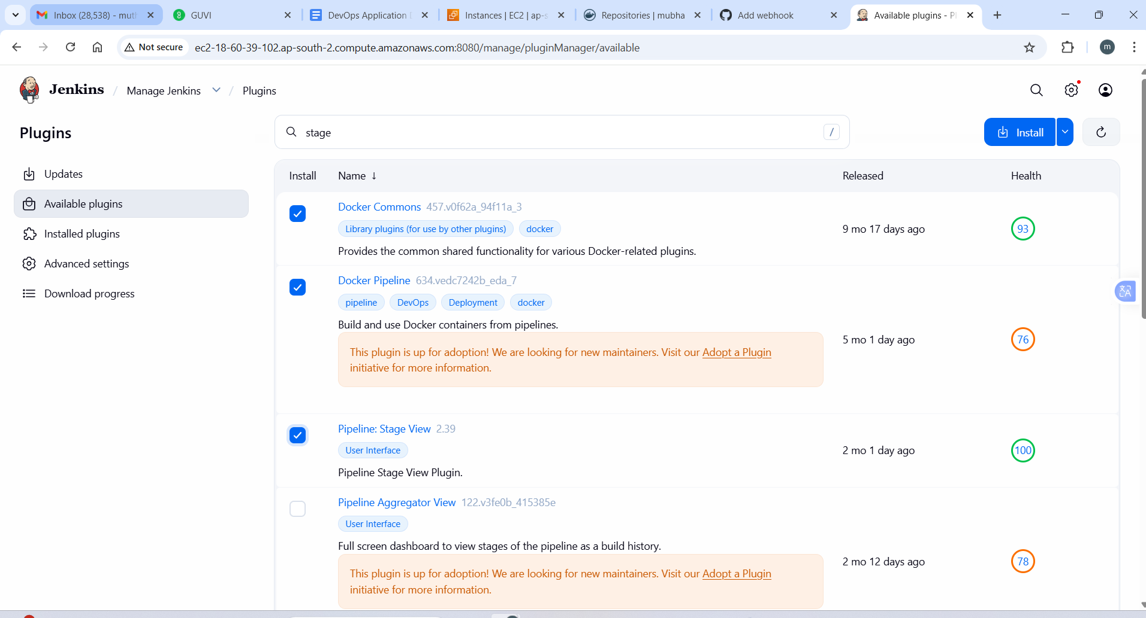

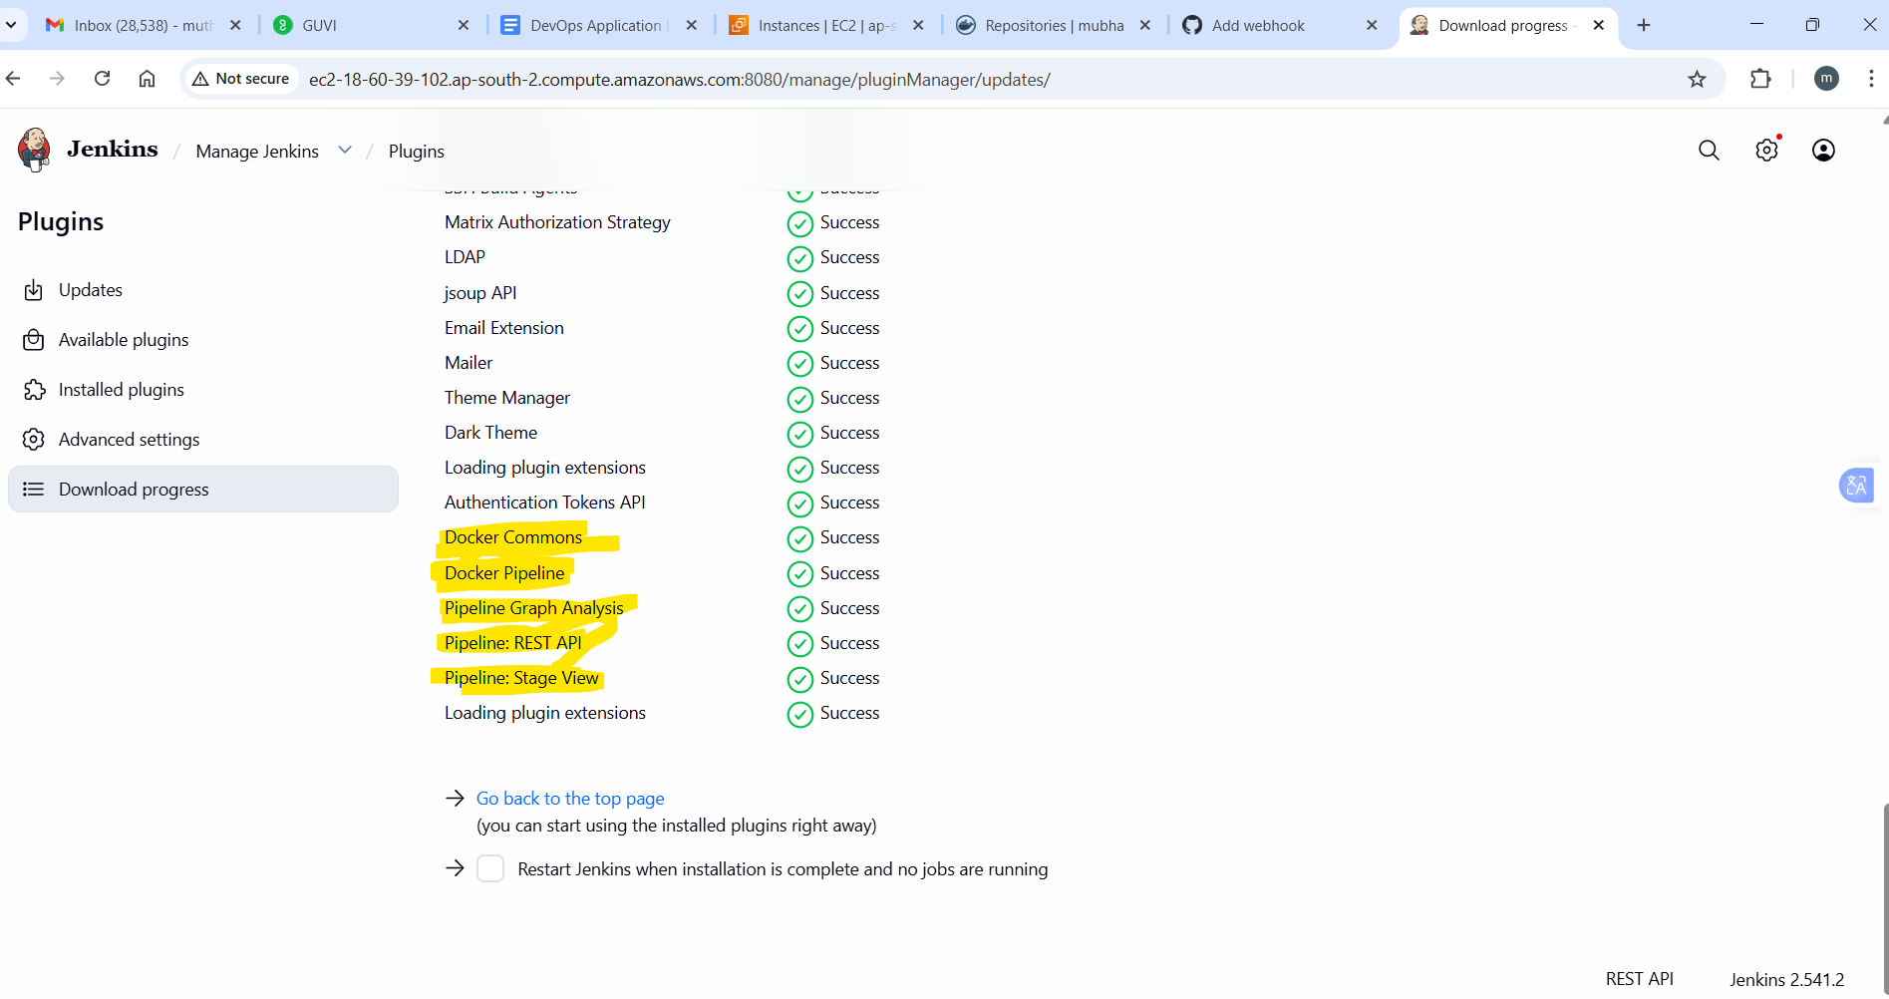

Adding webhook from Github with Jenkins

http://ec2-18-60-39-102.ap-south-2.compute.amazonaws.com:8080/

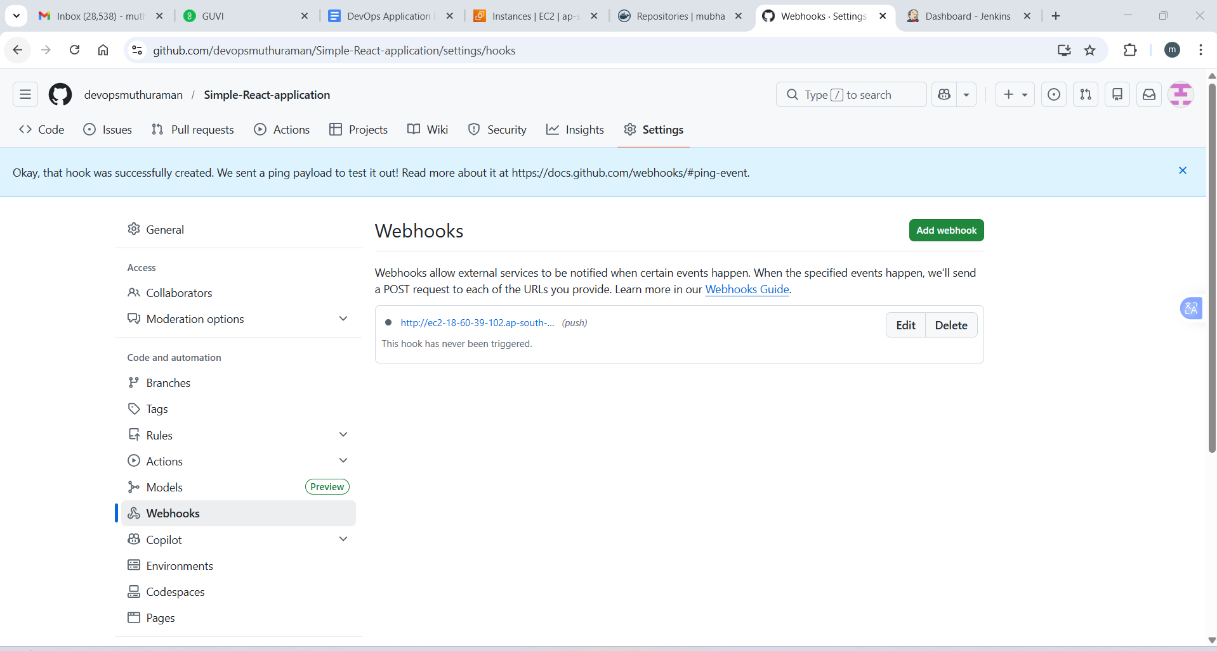

Adding GitHub project with Jenkins Job

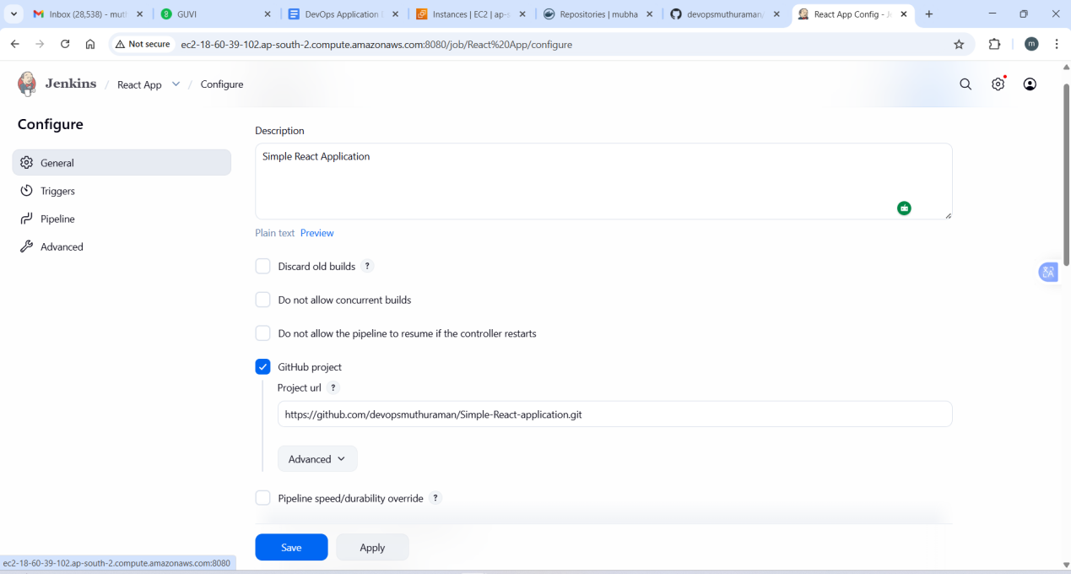

Select Pipeline script from SCM

